Kirin Harrington (NCFE10)

Kirin@twosmallpeople.co.uk

NCFE Level 2 Technical award in interactive media

Kirin Harrington

Contents

Introduction 1

Chosen interactive media product 2

Forms of interactive media products 2

Virtual reality 2

Augmented reality 3

Interactive PowerPoint 3

Website 4

Target audience 4

Platform/device 4

Virtual reality 5

Augmented reality 5

Interactive PowerPoint 5

Website 5

My choice of interactive media product 5

type of product 5

Features and services 5

Style/theme 6

Colours 6

Fonts 6

Sans serif vs serif fonts 6

My choice of fonts 6

Layout 7

navigation structure 7

Sources, processes and techniques 7

# Introduction

I have been asked by the mental health charity “Don’t Isol8” to create an interactive media product that will educate teenagers and young adults on how to improve mental health alongside encouraging open conversations when they are needed and give them access to support.

# Chosen interactive media product

## Forms of interactive media products

There are many different types of interactive media product and many different platforms that they work on, a few examples of these, alongside the features they can provide which would fit the brief I have been given, are listed below:

### Virtual reality

#### Pros

Virtual reality opens a whole new world of ways to display information and help people in a fun but also educational manner, this could involve a virtual reality “chat room” where the users could talk to each other in an open and anonymous environment, allowing them to talk freely about what’s on their mind without fear of being bullied for it.

It could also include games which allowed the user to learn more about mental health and ways to improve it, or even games which taught them important skills such as mindfulness or meditation techniques. It could also allow the user to take part in exercise, while in the world of virtual reality, which would allow them to connect to their friends at the same time and could provide a very valuable and immersive experience.

#### Cons

Although virtual reality provides an amazing space for users to talk and interact and enjoy themselves, it requires them to own a virtual reality headset, such as the oculus 2, which can be quite expensive and many people wont have access too, it also only allows the user to use it within their own home, which is not useful if the user needs support when they may be out and in a stressful situation, which is often likely, the anonymity also means that it’s possible for people to abuse their ability to speak freely and say harmful things, which would not positively affect someone mentally.

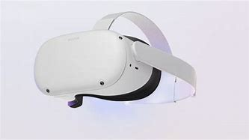

### Augmented reality

#### Pros

Augmented reality could be used as an app on a phone, which would provide accessibility and allow the user to use it wherever they go, which is a huge advantage, it could allow you to play games related to learning about mental health or encourage exercise through a game which requires you to run around collecting things.

It could also encourage the user to take part in mindfulness activities such as meditation, and even allowing users to communicate with each other, building friendships and opening up pathways for support, even over long distances

#### Cons

Not all phones work with AR, which means that it isn’t accessible to everyone, and not all environments will be suited for AR, it also distracts the user from the world around them which can be a problem as it can cause them to become disconnected and only involved in their phone.

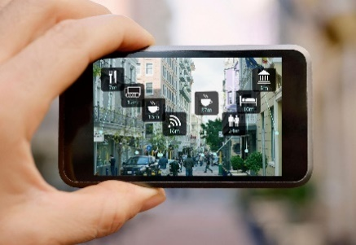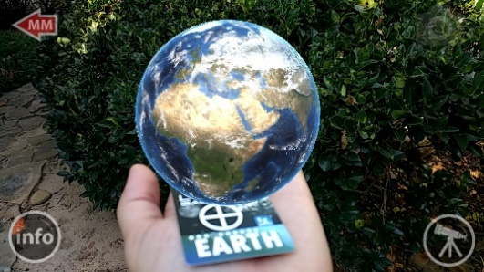

### Interactive PowerPoint

#### pros

Interactive PowerPoints can be shown on a TV screen basically anywhere, they allow the to swipe or tap to move on to a new screen which would give extra information on a certain area of mental health or ways to improve it, this could include videos and could also be made contactless with the use of sensors to remove any problems with breakages and any covid dangers. All media types, images, video and audio, would work well for this idea, images could be used in addition to text to provide information, allowing for a variety of ways to convey information, which could result in an intuitive and intuitive product.

#### cons

Interactive PowerPoints require a large screen or device and are stationary, meaning that the user would have to go and use one of them in a specific place, it would also mean that only a small number of people would have access to them and as it’s not portable they may not be able to use it when they need it the most.

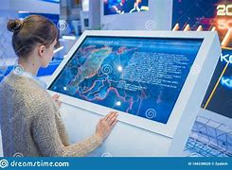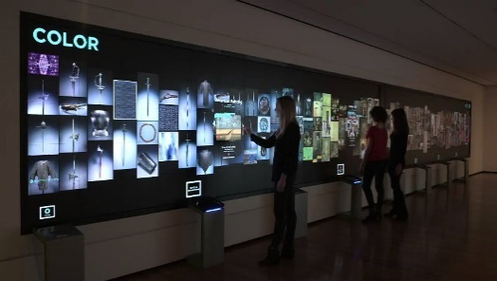

### Website

#### pros

A website is very portable, as users can access it from pretty much any device, allowing them to use It wherever they need to, it also allows for a variety of media methods such as images, videos and even games, alongside basic text to be used to convey information and allow the user to interact with the website in a variety of different ways, it could also provide a forum or a space for users to chat and talk about how they’re feeling, alongside information on other ways to get support or to improve their mental health condition.

#### cons

Websites can sometimes be slow if a lot of users are accessing them at once and require the user to have access to the internet, they also have a limited ability to provide support as they would have to refer the user to another service to do so.

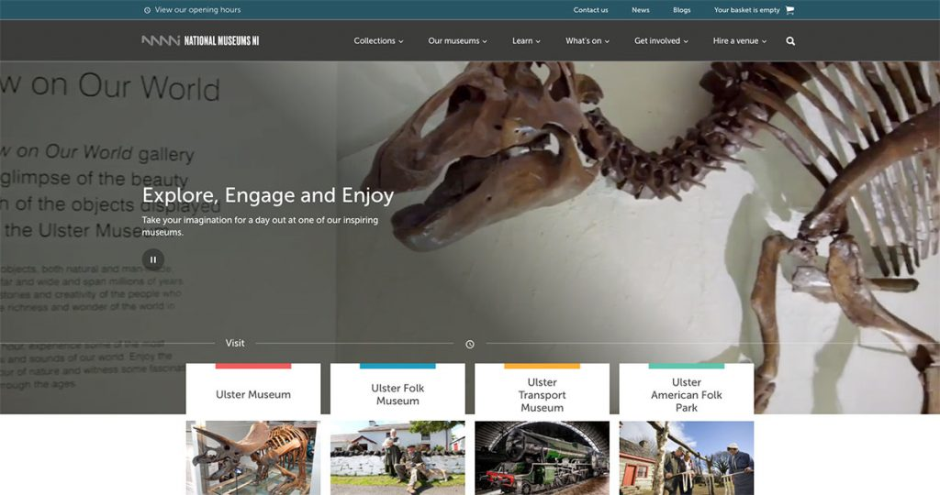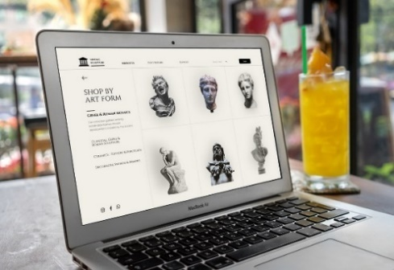

# Target audience

Considering the target audience when creating an interactive media product is very important, as you want to pick the correct platform and style to appeal to them, otherwise they may not enjoy using the product and may find it either too advanced, too basic, or even inaccessible.

## Platform/device

### Virtual reality

13+ Is very engaging and quite fun to use. However, it’s use is limited to people over the age of 13 because the headset will not fit on most young children. Some adults are wary and don’t feel comfortable with the technology as well, the chance of this seems to increase with the age of the adult, so the older the adult the higher the chance that they will refuse to use it.

### Augmented reality

3+ This would be useable by everyone as it is as simple as a phone app which needs little knowledge on how to use, apart from pointing it at the environment around you and reacting to what you see, it also appeals to a wide range of people as animations are interesting, especially to young audiences which could get them engaged and older audiences can focus more on the information.

### Interactive PowerPoint

5+ Useable by most with the exception of people who are too short to use the touch screen, this is easily fixed with a step or just a lower screen however, it would add an interactive element and can make a display more interesting for everyone rather than just blocks of text which some people may just ignore.

### Website

12+ Can be used by almost anyone as it is viewable on almost any device, it often contains more text and less interactivity and therefore is a lot less appealing to younger children, older children and adults also may have their own phone meaning that they don’t have to borrow their parents which improves accessibility.

# My choice of interactive media product

## type of product

For my interactive media product, I have chosen to go with a website as it is accessible to nearly everybody through a smartphone and can be used anywhere. A website is a simple yet highly effective way of conveying information and can appeal to users in a variety of ways, it fits the target age demographic of teenagers and young adults as they will nearly all have access to a smartphone and will understand how to use a website, it is also highly intuitive and can offer a range of features and ways to portray information, such as videos which could teach the user how to improve their mental health and the techniques to do so, as well as providing a space for users to chat or links to other services where they could get support.

## Features and services

My product will aim to offer a wide variety of features and services, which would include:

* A forum which would allow users to talk to each other and open up about issues they are facing
* Informational images, text and potentially videos which would allow the user to learn about different ways to improve their mental health and tech them how to apply them
* Inform users about events they can attend which will help them connect with others who have had similar experiences and make new friends, opening up more lines of support
* Inform users about exercise sessions near them and encourage them to take part in the exercise
* Offer instructions on how to perform mindfulness exercises
* Offer interactive quizzes to help the user learn about potential mental health issues and how to support others with them

# Style/theme

## Colours

As it is a mental health app for teenagers and young adults I have chosen to go with cool and calming colours, as the experience needs to be relaxing and supportive and develop a sense of calm and safety in the user, allowing them to talk freely without being too scared to do so. Bright colours would have appealed a lot more to a younger audience and could be overwhelming, especially if the user is already stressed. I chose colours mainly related to blue as “Blue calls to mind feelings of [calmness](https://www.verywellmind.com/ways-to-calm-down-quickly-when-overwhelmed-3145197) and [relaxation](https://www.verywellmind.com/tips-to-reduce-stress-3145195). It is often described as peaceful, tranquil, secure, and orderly.” – taken from [The Colour Blue: Meaning and Colour Psychology (verywellmind.com)](https://www.verywellmind.com/the-color-psychology-of-blue-2795815)

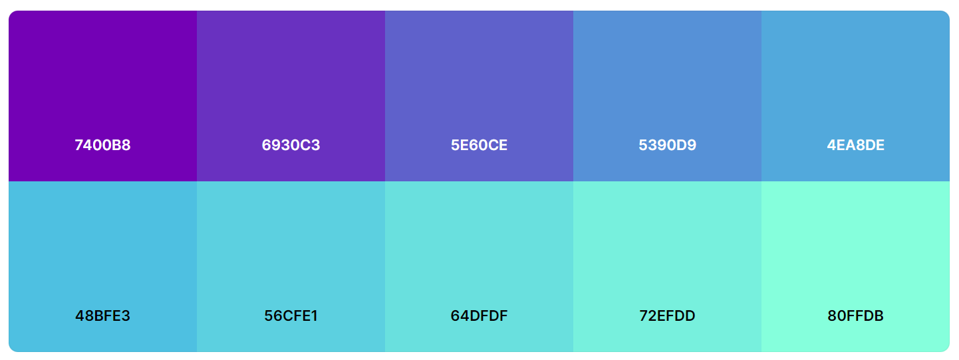

## Fonts

### Sans serif vs serif fonts

Picking between Sans-Serif and Serif fonts can be a difficult and important choice, as it will change the overall feel and look of the website and may make it harder to read and understand for some people with worse eyesight or conditions like dyslexia.

#### Sans serif

Fonts such as “Arial” and “Daytona” are examples of Sans-Serif fonts, as they don’t have extra lines (or “serifs”) attached to the letters, this results in a much more formal and orderly look, and can be a lot easier to read, especially in bulk and with smaller font sizes, it is also a lot easier for people with bad eyesight or conditions like dyslexia to read, which is very important when creating a website which needs to be accessible to everyone.

#### serif

Fonts such as “Segoe Script” and “Forte” are examples of Serif fonts, as they involve extra lines, which can improve the look and highlight areas of text, causing them to be look more professional, especially in titles.

### My choice of fonts

#### Font type

For my interactive media product, I chose to go with a combination of “Helvetica” for the main body of text, and “Futura” for titles and headings, this is because the product needs to be accessible to all teenagers and young adults, and Serif fonts can be a lot harder to read, they also create a much more calming feel as they don’t require as much effort to read due to them being so much easier to understand.

#### Font size

For the size of the fonts I will use, I decided to go with 18 for headings and titles, and 14 for the main bodies of text, this is to ensure that they are easy to distinguish between, alongside also being large enough for anyone to read, which would improve accessibility, and allow all teenagers and young adults to use.

# Layout

# navigation structure

# Sources, processes and techniques

